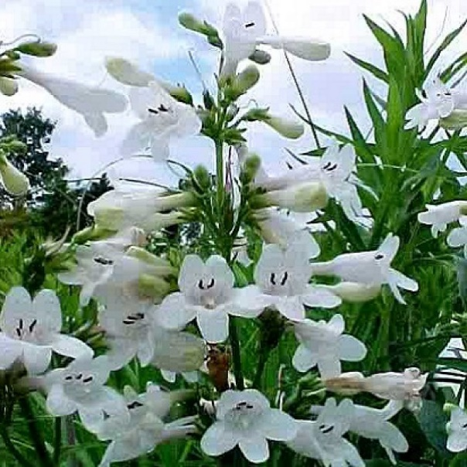
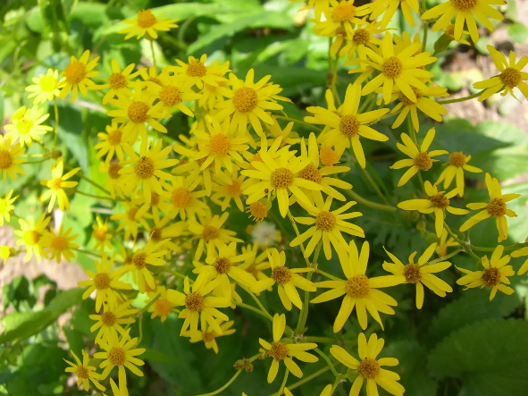
Healthy Yards Monroe County
In association with the
Penfield Community Victory Garden
Presents
Native Plant Sale Fundraiser
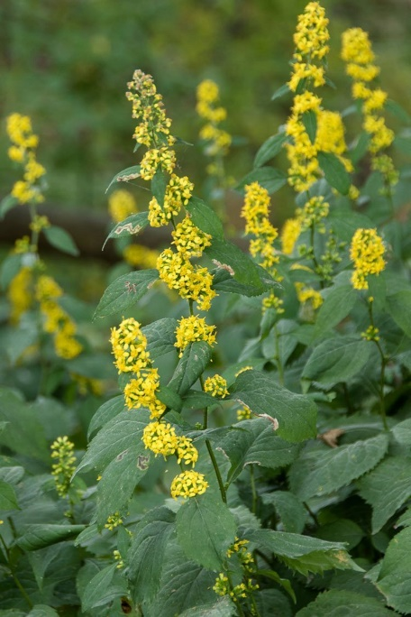
When: Saturday, May 20, 2023
10 am – 2 pm (Rain or Shine)

What: Healthy Yards Monroe County will have a booth selling native plants (See list below)

Where: Penfield Recreation Community Center Grounds
1985 Baird Road
Penfield, NY 14625

- A large selection of native plants suitable for sun and shade for sale by Healthy Yards Monroe County!
- 19 different selections to choose from!
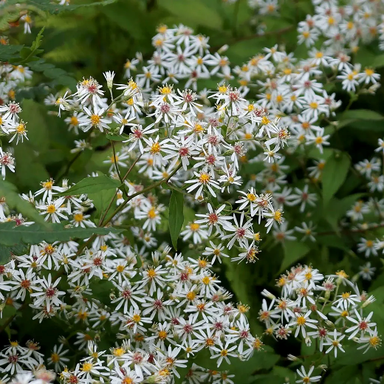
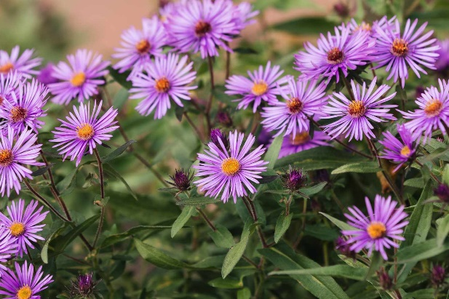
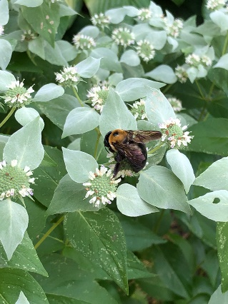
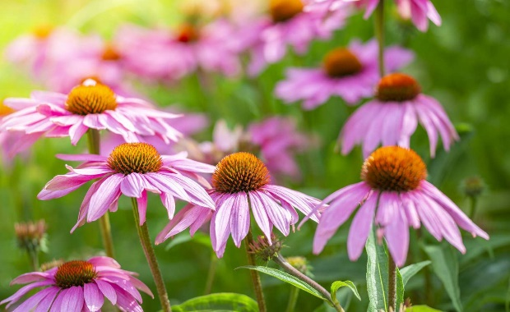
- Maidenhair Fern, White Wood Aster, Great Blue Lobelia, Golden Groundsel, Zigzag Goldenrod, Foamflower, Large Leaf Aster, Foxglove beardtongue, Purple Coneflower, Boneset, Pink Beebalm, Clustered Mountain Mint, Blue Wood Aster, New England Aster, Smooth Aster, Culver’s Root, Shorts Golden Rod, Rough Goldenrod

